3981 Timber Trail, Memphis, TN 38115
Stars below represent properties under management by CB properties
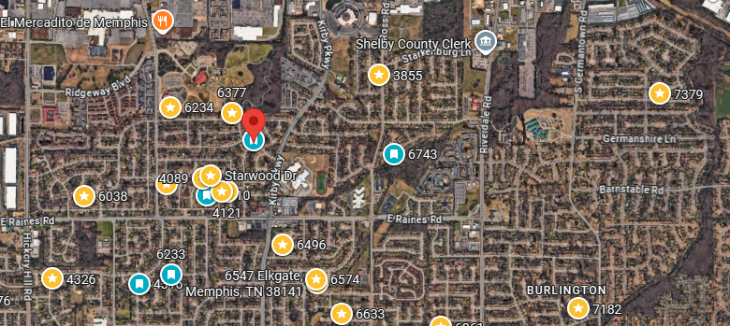
Bed/Bath: 3/2
Square Foot: 1,442
Year Built: 1981

Area Overview: This home is located near Bill Morris Parkway/385, which provides easy access to I-240. The location by 385 allows for access to the suburbs and major economic centers of Memphis in a matter of minutes. This is considered a high class C area.

A/C – 2017
Furnace - 2017
Hot Water Heater –2014
Roof – approximately 10 years
This home is occupied on a month to month

