5218 Nelbrook Drive, North Little Rock, AR 72118
Stars below represent properties under management by Turnkey Property Managemnet
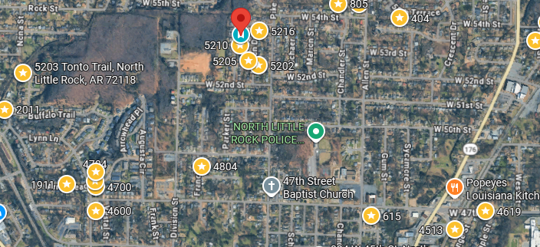
Bed/Bath: 3/1
Square Foot: 954
Year Built: 1959

Area Overview: This home is located in the North Little Rock and Levy area. This is conveniently located to I 30 and I 40 and Hwy 167. Easy access to the suburbs and to the city, including the River Mart downtown. Individuals like being inNorth Little Rock for the community and schools. Points of interest include the Verizon Arena, ArkansasRiver Trail and McCain Mall.
New Roof
Furnace – 2004
A/C – 2023
Hot Water Heater – 2018
Sewer inspected and all ok

