9417 Woodford Drive, Little Rock, AR 72209
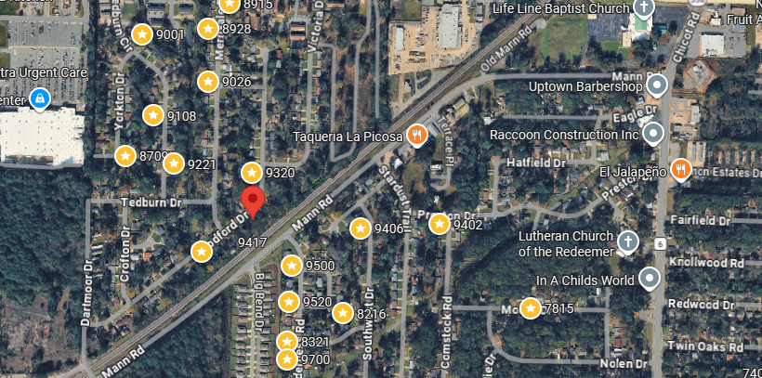
Bed/Bath: 3/1
Square Foot: 942
Year Built: 1962

Area Overview: This home is part of Southwest Little Rock. This area is one of the most culturally and economically diverse sections of the city.

Furnace – 2022
Roof – 2022
This home is occupied through August of 2028

