4431 Shadow Leaf Cove North, Memphis, TN 38128
Stars below represent properties under management by CB properties
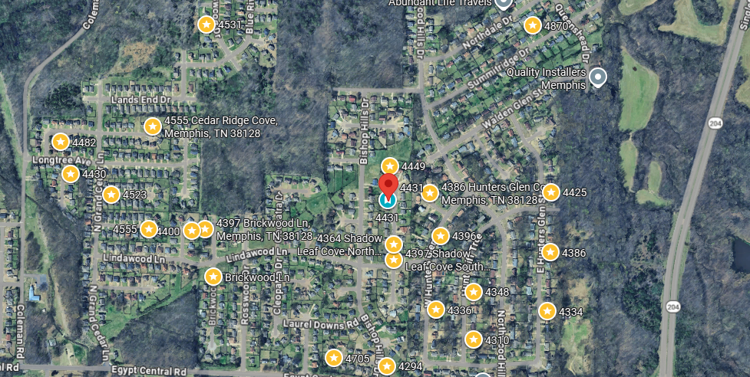
Bed/Bath: 3/2
Square Foot: 1,087
Year Built: 2000

Area Overview: Raleigh is an area that consists of neighborhoods in North Memphis outside the I 240 loop. Austin Peay highway runs through the area that has everything you need from restaurants, grocery shopping, shopping malls/ retail and a newly built Raleigh Springs Civic Center and Covington Pike! 38128 and 38133 are the primary zip codes with 10+ public schools and a large presence of rentals. Amazon and Nike both have large distribution centers in the area that have large employment opportunities. Raleigh-Millington, Scenic Hills, Lakewood, and Springhill are a few of the neighborhoods within the area that are B Class areas with consistent rent increases coupled with solid appreciation

AC – 2019
Furnace - 2019
Hot Water Heater –2023
Roof – less than 5 years old
Occupied through August of 2028
No City Taxes

