3905 Pine Cone Drive, Little Rock, AR 72209
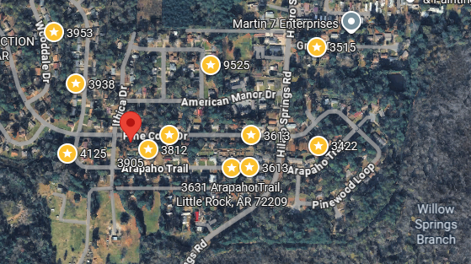
Bed/Bath: 4/1.5
Square Foot: 1,181
Year Built: 1965

Area Overview: Cloverdale Watson area of Little Rock. The neighborhood and shopping district were developed in the mid 1960’s. The area has a nice, established feel to it; wide streets and mature trees. It is located within ½ mile of I-30, a major interstate through Arkansas that connects directly with downtown Little Rock and feeds into both of the major freeways in Little Rock (430 and 630). The area is solid blue-collar, with many residents working in nearby industrial, small business and warehousing jobs along I-30 corridor.

Furnace – 2018
A/C - 2018
Hot Water Heater –2022
Roof – approximately 12 years old
This home is occupied through October of 2027

