3420 Forrester Road, Memphis, TN 38109
Stars below represent properties under management by CB properties
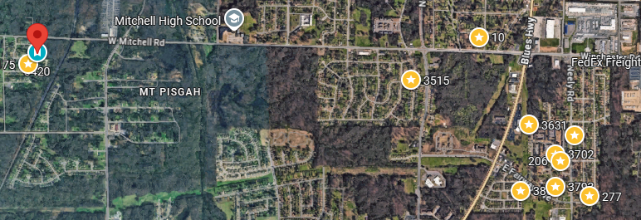
Bed/Bath: 3/1
Square Foot: 1,051
Year Built: 1972

Area Overview: 38109 is an established area in South Memphis near Graceland (Home of Elvis!), the Memphis International Airport, the Fedex Hud (largest employer in the city) and just South of downtown at the Tn/ MS state border. The home is located in the Chickasaw Village/ Whitehaven area which is a quiet, old school Memphis neighborhood! People who live in the area either grew up near by or still have family roots in the area today! It is conveniently located near highway 61 and the I 240 loop which circles the city of Memphis. Commute to work is low and easy access to shopping like retail and grocery. Plenty of elementary and high schools in the area to make it attractive for people to live in the area. Area is easy to rent and has steady appreciation with it being a low B Class area to invest in with plenty of upside!
New Furnace
New AC
Hot Water Heater - 2025
Sewer line inspected and all ok – replace clean out
*Utilities and lawn care are not a part of the renovation budget*

