2988 Clearbrook Street, Memphis, TN 38118
Stars below represent properties under management by CB properties
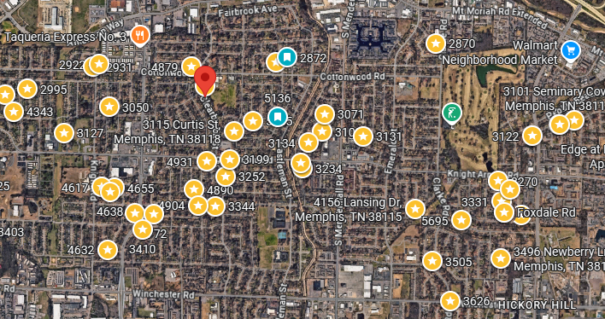
Bed/Bath: 3/2
Square Foot: 1,719
Year Built: 1961

Area Overview: This home is in Parkway Village. What we like about the area is the history we have in the neighborhood of quick renting, which is a common theme for houses inside and close to the 240 loop. The area is close to I-240, which gives quick access to most parts of the city within 25 minutes, including the airport/Fed Ex area and other logistics jobs that is the driver of the Memphis economy in 15 minutes.

Occupied through December of 2027

