1700 Sanford Drive, Little Rock, AR 72227
Stars below represent properties under management by Turnkey Property Management
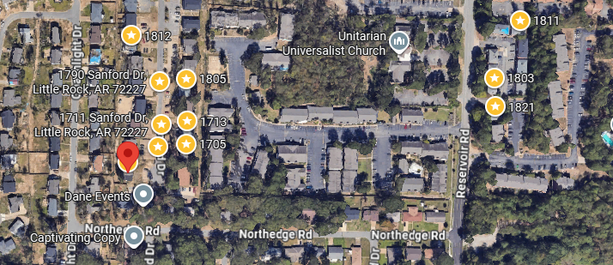
Bed/Bath: 2/1.5 each unit
Square Foot: 4,680
Year Built: 1972

Area Overview: The Reservoir/Sturbridge area is centrally located in the city of Little Rock. Major travel corridors and freeways, such as Rodney Parham, Cantrell Road, 430 and 630 Freeways are all within a 10 minute drive of this 4 unit building. Numerous restaurants, retail, grocery stores are within a 5 minute drive. Close- by examples include Marshalls, Starbucks, Natural Grocers and US Pizza Company. We like this area because of the high-level of desirability to residents. As previously mentioned, the neighborhood is centrally located and access to numerous lifestyle amenities. Additionally, the multifamily units have a neighborhood feel, along with actually being a part of a much larger single-family community. Finally, these units offer the opportunity for a resident to live affordably in an area where they may not be able to otherwise live.
Roof - 2025
Unit 1 – Furnace – 2016, A/C – 2016, Hot Water Heater – 2015
Occupied month to month
Unit 2 – Hot Water Heater – 2023, Furnace 2011
Occupied month to month
Unit 3 – Furnace - 2011, A/C – 2012, How Water Heater – 2023
Occupied through November of 2028
Unit 4 – Furnace 2002, A/C – 2023, Hot Water Heater – 2022
Occupied through February of 2027

