932 Cullenwood Drive, Memphis, TN 38116
Stars below represent properties under management by CB properties
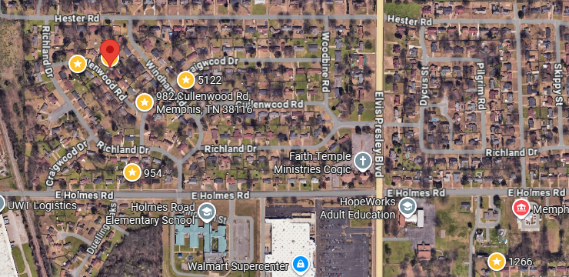
Bed/Bath: 3/2
Square Foot: 1,339
Year Built: 1958

Area Overview: South Memphis is known as Whitehaven and is one of the biggest areas in Memphis in population and area. This area is situation outside the I 240 loop with I 78 and I 55 running through the middle that takes you into MS. Memphis is known for logistics and industrial jobs and most all companies from FedEx, International Paper, AutoZone, BNSF, Amazon have a presence in the area to be close to the International Airport. This area caters to families with children for the most part and typically homes are on bigger lots and more square footage. Zip codes consist of 38118 and 38116, 38141 with neighborhoods like Oak haven and Parkway Village centralized within the community. Most areas are considered Low B Class to Solid B Class.
A/C – 2015
Furnace – 2016
Hot Water Heater – 2016
Roof – Approximately 10 years old
Occupied through January of 2027

