9122 Tanya Drive, Little Rock, AR 72204
Stars below represent properties under management by Turnkey Property Management
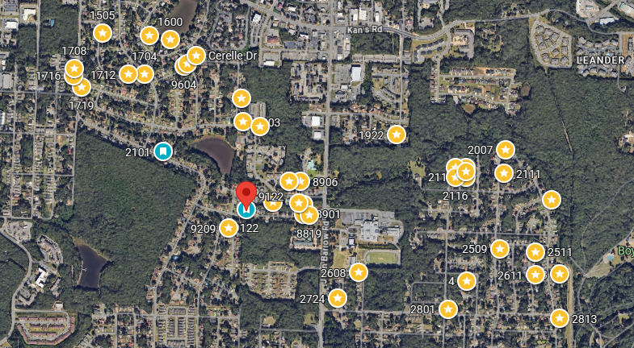
Bed/Bath: 2/2 each side
Square Foot: 2,320
Year Built: 1973

Area Overview: The John Barrow Addition of Little Rock is a neighborhood in the western portion of the city, named for its main thoroughfare, John Barrow. It is bordered on the north by I-630, on the west by I-430, on the east by Boyle Park, and on the south by Asher Avenue. Nearby neighborhoods include Briarwood, Rosedale, and Broadmoor. The University of Arkansas at Little Rock, Baptist Health Medical Center and its campus of physician offices and surgery centers are located close to this neighborhood. The entire area is basically an extension of Midtown. Nearby shopping developments include Midtown Mall/Park Avenue and Shackleford Crossing likes to the immediate east and west of the area.

**Cash flow opportunity while renovations are going on**

