9107 Ricky Lane, Little Rock, AR 72209
Stars below represent properties under management by Turnkey Property Management
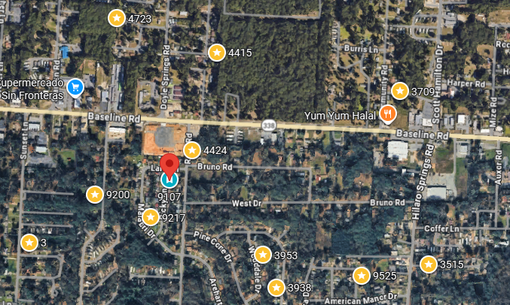
Bed/Bath: 4/2
Square Foot: 1,160
Year Built: 1970

Area Overview: Southwest Little Rock is one of the most culturally and economically diverse section of the city. The area is home to many of our minority groups, including a large number of Latinos. The portion of city is home to many working class / blue collar families. These residents choose to live and work in SWLR for a variety of reasons. Reasons include the fact that SWLR hosts a diverse economy and Investments continue in the area. SWLR is also home to the Arkansas Department of Transportation Headquarters and the Arkansas State Police Headquarters. Numerous warehousing, manufacturing and industrial businesses call SWLR home too.
Roof – 8-10 years old

