6930 Autumnhill Lane, Bartlett, TN 38135
Stars below represent properties under management by CB properties
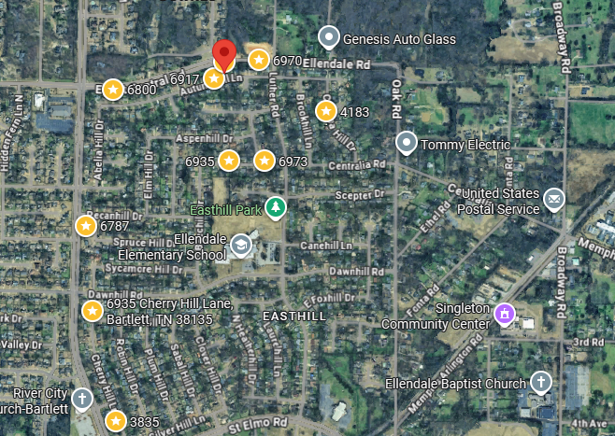
Bed/Bath: 3/2
Square Foot: 1,343,
Year Built: 1984

Area Overview: Bartlett has always been a highly desirable place to live. It is a family friendly suburb of Memphis, known for its quiet residential feel, strong municipal services and top rated schools. It offers a safe suburban lifestyle with retail shopping nearby while retaining a small town feel. Easy access to I-40 and I-240. The town maintains over 30 parks including Freeman Park which provides ample biking and walking trails. A growing number of new developments and a stable high value real estate market.

