6618 Elmore Road, Little Rock, AR 72209
Stars below represent properties under management by Turnkey Property Management
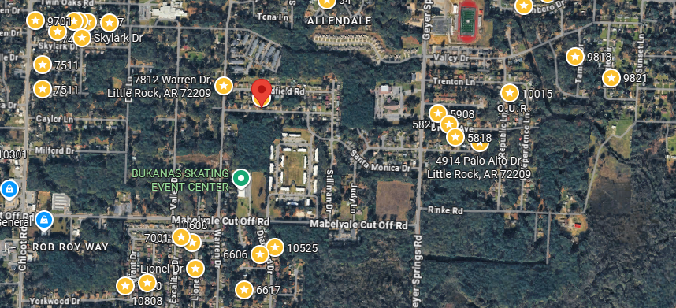
Bed/Bath: 4/2
Square Foot: 1,892
Year Built: 1979

Area Overview: This home is located in the Cloverdale/Watson Neighborhood. The Cloverdale Watson area of Little Rock has a lovely, established feel to it, with wide streets and mature trees. The neighborhood and shopping district were developed in the mid-1960s. Within a half-mile is I-30, a major interstate through Arkansas. I-30 connects directly with downtown Little Rock and feeds into both of the major freeways in Little Rock (430 and 630). The area is solidly blue-collar, with many residents working in nearby industrial and warehousing jobs along the I-30 corridor.

Furnace – 2020
A/C - 2020
Hot Water Heater –2016
Sewer inspected and repairs made

