4420 Owen Road, Memphis, TN 38122
Stars below represent properties under management by CB properties
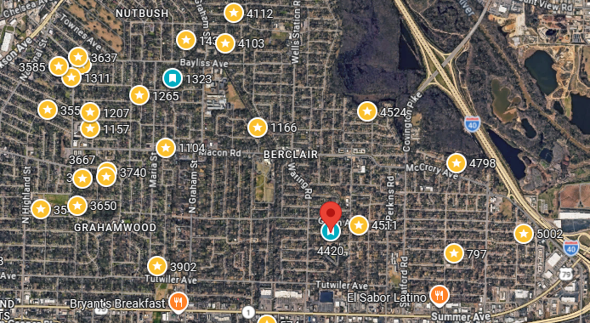
Bed/Bath: 3/1
Square Foot: 1,073
Year Built: 1955

Area Overview: Berclair Area is located in East Memphis and consists of 38122 and 38112 zip codes. This area is centralized within the city of Memphis within the I 240 loop and Sam Cooper Blvd. The different neighborhoods within this area are Grahamwood, Nutbush, the Heights and Highland Heights. We have always operated within this are because of the high demand in renters, the strong cultural diversity and the busy commercial corridor along Summer Avenue that runs through the middle. Everything you need is within a few minutes’ drive. Grocery shopping, shopping centers/ retail, banks, restaurants, hardware stores, you name it! This area continues to be in high demand for investors and is a solid B Class area! *Utilities and yard maintenance are not calculated in the cash flow*

Furnace – 2025
A/C - 2024
Hot Water Heater –2026
Roof – October of 2024

