4336 W Hunters Glen Street, Memphis, TN 38128
Stars below represent properties under management by CB properties
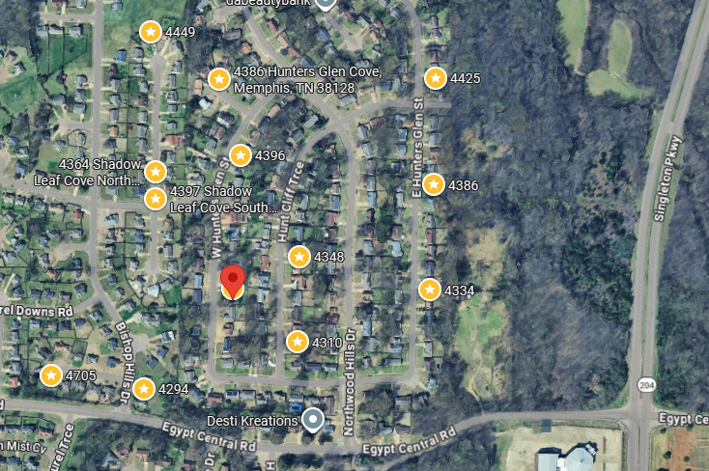
Bed/Bath: 3/2
Square Foot: 1,577
Year Built: 1977

Area Overview: Raleigh is an area that consists of neighborhoods in North Memphis outside the I 240 loop. Austin Peay highway runs through the area that has everything you need from restaurants, grocery shopping, shopping malls/ retail and a newly built Raleigh Springs Civic Center and Covington Pike! 38128 and 38133 are the primary zip codes with 10+ public schools and a large presence of rentals. Amazon and Nike both have large distribution centers in the area that have large employment opportunities. Raleigh-Millington, Scenic Hills, Lakewood, and Springhill are a few of the neighborhoods within the area that are B Class areas with consistent rent increases coupled with solid appreciation

