8005 Woodhaven Drive, Little Rock, AR 72209
Stars below represent properties under management by Turnkey Property Management
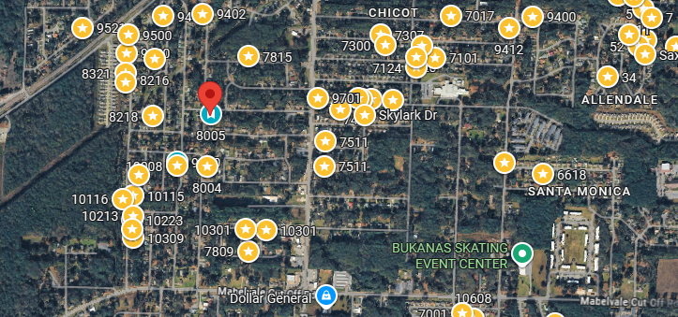
Bed/Bath: 4/2
Square Foot: 1,461
Year Built: 1972

Area Overview: Southwest Little Rock is one of the most culturally and economically diverse sections of the city. The area is home to many of our minority groups, including a large number of Latinos, as well as many working class/blue collar families reside here. SWLR is also home to the Arkansas Department of Transportation Headquarters and the Arkansas State Police Headquarters. Numerous warehousing, manufacturing and industrial business call SWLR home

HVAC – 2020
Hot Water Heater –2017
Roof – less than 3 years old
Sewer line will be rooted

