5501 Halifax Drive, Little Rock, AR 72209
Stars below represent properties under management by Turnkey Property Management
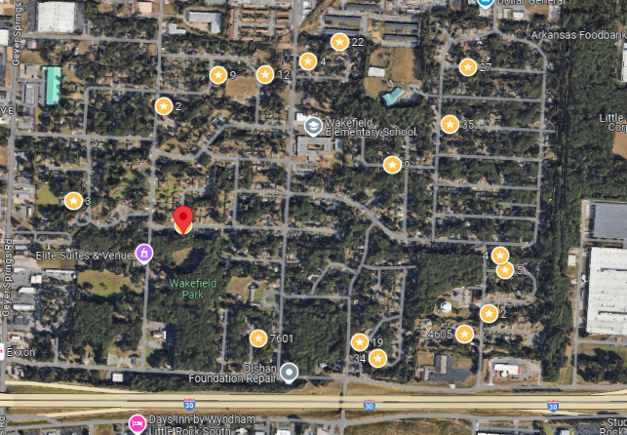
Bed/Bath: 3/1.5
Square Foot: 948
Year Built: 1966

Area Overview: Southwest Little Rock is one of the most culturally and economically diverse sections of the city. The Arkansas Times recently published “If the River Market is our Manhattan and Hillcrest is our Brooklyn, consider Southwest Little Rock our Queens. The Arkansas Times article pointed out the cultural diversity. The area is home to many of our minority groups, including a large number of Latinos, as well as many working class/blue collar families reside here. SWLR is also home to the Arkansas Department of Transportation Headquarters and the Arkansas State Police Headquarters. Numerous warehousing, manufacturing and industrial business call SWLR home
Hot Water Heater and HVAC – 2023
Roof – approximately 12 years old
Occupied through May of 2027

