3064 Greenbranch Drive, Memphis, TN 38118
Stars below represent properties under management by CB Properties - Memphis, TN
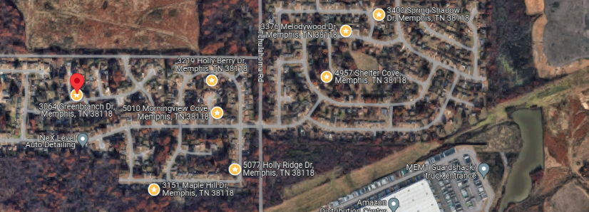
Bed/Bath: 3/2
Square Foot: 1,420
Year Built: 1975

Area Overview: This property is located in the Whitehaven area of Memphis. Whitehaven is best known globally for Graceland, but locally, it is known for its residents’ pride in living within the Whitehaven area and for locally-owned minority businesses. The houses are typically larger, with covered parking and a floor plan that, along with our renovation, helps properties to rent fast. Most houses in Whitehaven are 10 minutes from the airport area, which is a source for thousands of jobs. Whitehaven is the largest community that is close to the Tunica Casinos in Mississippi, also a source of thousands of jobs.

The 2024 renovation highlights include:

- New roof, HVAC & Hot water heater
- Freshly painted inside and out
- GFCI outlets in all wet locations
- Vinyl plank flooring
- Sewer inspection completed and all in good working order
This home is occupied through March of 2027

