285 Kelso Road, Jacksonville, AR 72076
Stars below represent properties under management by Turnkey Property Management
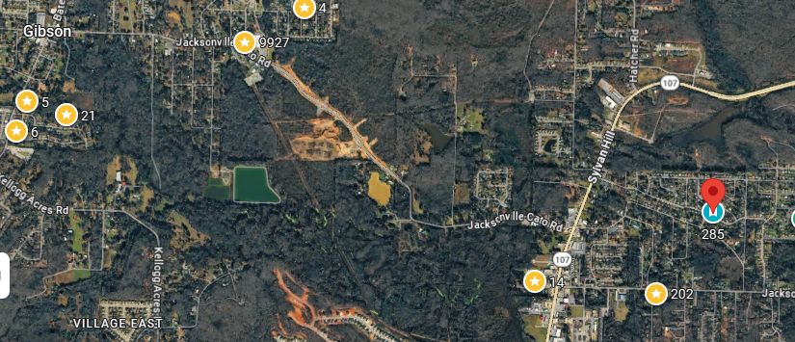
Bed/Bath: 3/2
Square Foot: 1,124
Year Built: 1982

Area Overview: Sherwood and Jacksonville are vibrant neighboring cities just northeast of Little Rock offering a family friendly suburban, military oriented lifestyle. Quiet, residential feel with 18 parks and the notable Greens at North Hills golf course, along with the Air Force base.

AC – 2011
Furnace - 2010
Hot Water Heater –New
Roof – back half to be replaced

