1301 Stafford Road Sherwood, AR 72120
Stars below represent properties under management by Turnkey Property Management
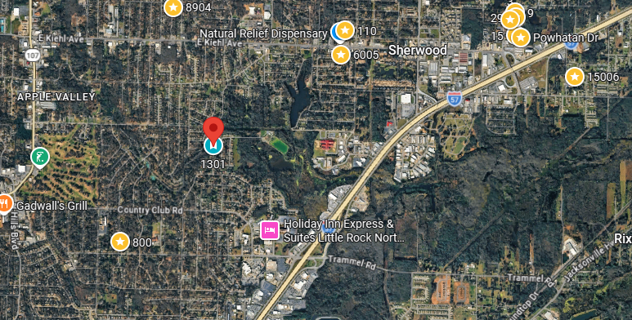
Bed/Bath: 3/2
Square Foot: 1,721
Year Built: 1972

Area Overview: The city of Sherwood is a direct neighbor of the City of North Little Rock. Many people can’t tell when they have left North Little Rock and entered Sherwood, as they share many amenities, employers, roads and highways. The two cities have grown simultaneously.
Roof – 2025
New HVAC
Hot Water Heater – 2022
Sewer line inspected and all ok

