3146 Nathan Avenue, Memphis, TN 38112
Stars below represent properties under management by CB properties
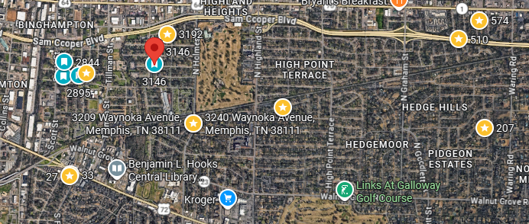
Bed/Bath: 4/2
Square Foot: 1,665
Year Built: 2026

Area Overview: Binghampton is a rapidly, evolving diverse neighborhood in the center of Memphis. There is a strong sense of community, historic charm and near the vibrant, artistic Broad Avenue arts district. Once a very industrial area it now featurs revitalized spaces, local businesses, community gardensand improved accessiblity near the Hampline bike route – which connects Overton Park to the Shelby Farms Greenline. This area is about 5 minutes from Downtown Memphis. All of this makes it an attractive option for investors as property values are continuing to improve.

