5136 Christopher Avenue, Memphis, TN 38118
Stars below represent properties under management by CB properties
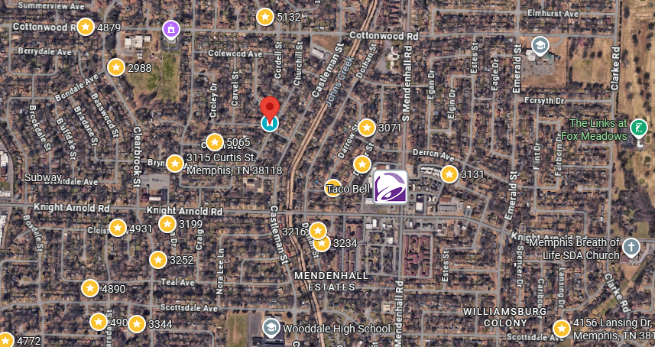
Bed/Bath: 3/2
Square Foot: 1,732
Year Built: 1960

Area Overview: As you can see by the map, our in-house management has a large exposure to the area which is helpful in creating efficiencies to the day to day management. This resident is going to renew his lease we are currently working on the paperwork.

