7017 Fairfield Drive, Little Rock, AR 72209
Stars below represent properties under management by CB properties
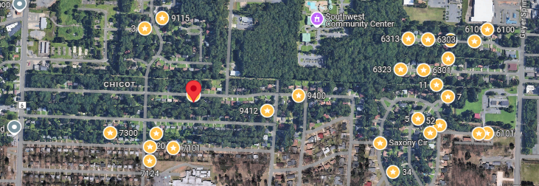
Bed/Bath: 3/1
Square Foot: 910
Year Built: 1964

Area Overview: Southwest Little Rock is one of the most culturally and economically diverse sections of the city. The
Arkansas Times recently published “If the River Market is our Manhattan and Hillcrest is our Brooklyn, consider
Southwest Little Rock our Queens. The area is home to many of our minority groups, including a large number of Latinos,
as well as many working class/blue collar families reside here.

