1719 Junior Deputy Road, Little Rock, AR 72205
Stars below represent properties under management by Turnkey Property Management
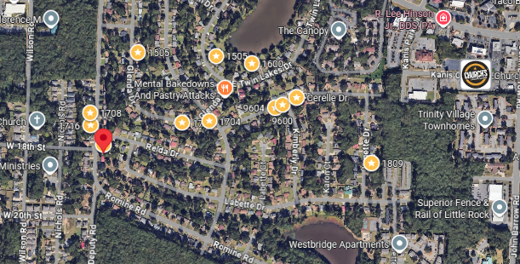
Bed/Bath: 3/2
Square Foot: 1,024
Year Built: 1970

Area Overview: This home is in the Twin Lakes Neighborhood in the western portion of the city. Nearby neighborhoods include Briarwood, Rosedale, Broadmoor. The University of Arkansas at Little Rock, Baptist Health Medical Center and its campus of physician offices and surgery centers are located close to this neighborhood. The entire area is basically an extension of Midtown.

HVAC – 2021
Hot Water Heater – 2017
New Roof
Sewer inspected and all ok

