4493 Westmont Drive, Memphis, TN 38109

*Stars below represent properties under management by CB Properties - Memphis, TN*

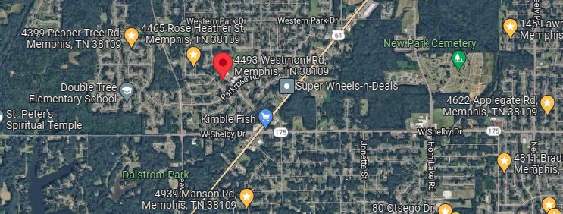

**Bed/Bath:** 3/2

**Square Foot:** 1,106

**Year Built:** 1961

Area Overview: This home is located in the Westwood neighborhood of Memphis. It is off

Highway 61 near the TN/MS state line - about 10 minutes from the airport area, which

is a good source for jobs. It is also a short commute to the Tunica Casinos in Mississippi,

which is a good source for jobs as well.

HVAC – 2020

Hot Water Heater – 2023

https://turnkeyproperties.box.com/v/MarketingPhotos4493Westmont