1809 Lynette Drive, Little Rock, AR 72205

*Stars below represent properties under management by Turnkey Property Management*

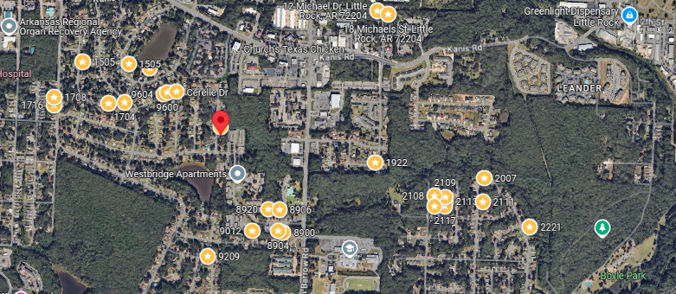

**Bed/Bath:** 3/2

**Square Foot:** 1,188

**Year Built:** 1975

Area Overview: The **John Barrow Addition** of [Little Rock](https://en.wikipedia.org/wiki/Little_Rock,_Arkansas) is a neighborhood in the western portion of the city, named for its main thoroughfare, John Barrow. It is bordered on the north by I-630, on the west by I-430, on the east by Boyle Park, and on the south by Asher Avenue. Nearby neighborhoods include [Briarwood](https://en.wikipedia.org/wiki/Briarwood,_Little_Rock,_Arkansas) to the north and [Rosedale](https://en.wikipedia.org/w/index.php?title=Rosedale,_Little_Rock,_Arkansas&action=edit&redlink=1) to the south, while to the east sits [Broadmoor](https://en.wikipedia.org/wiki/Broadmoor,_Little_Rock,_Arkansas) and the vicinity surrounding the [University of Arkansas at Little Rock](https://en.wikipedia.org/wiki/University_of_Arkansas_at_Little_Rock). To the north sits Baptist Health Medical Center and its campus of physician offices and surgery centers. The entire area is basically an extension of Midtown. Nearby shopping developments Midtown Mall/Park Avenue and Shackelford Crossing lie to the immediate east and west of the area. There is also easy access to two major freeways (430 and 630).

HVAC – 2023

Hot Water Heater – 2019

Roof – approximately 9 years old