5205 Wycliffe Drive, Little Rock, AR 72209

*Stars below represent properties under management by Turnkey Property management*

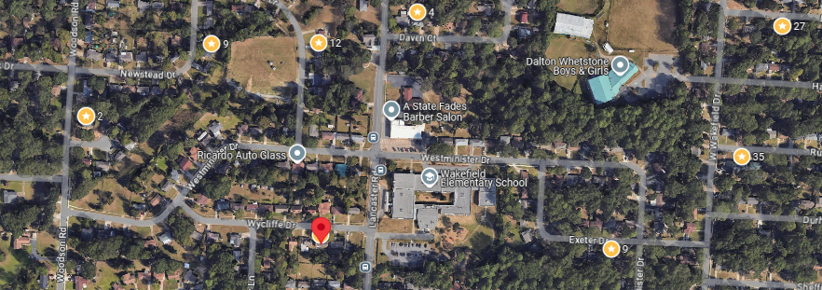

**Bed/Bath:** 3/1.5

**Square Foot:** 948

**Year Built:** 1964

Area Overview: Southwest Little Rock is one of the most culturally and economically diverse sections of the city. The Arkansas Times recently published “If the River Market is our Manhattan and Hillcrest is our Brooklyn, consider Southwest Little Rock our Queens. The Arkansas Times article pointed out the cultural diversity. The area is home to many of our minority groups, including a large number of Latinos, as well as many working class/blue collar families reside here. The Little Rock Children’s Hospital constructed a $4 million primary care clinic there, with an emphasis on providing a bilingual staff to service the local community. SWLR is also home to the Arkansas Department of Transportation Headquarters and the Arkansas State Police Headquarters. Numerous warehousing, manufacturing and industrial business call SWLR home

AC – 2005

Furnace - 2022

Hot Water Heater – 2005

Roof – 5-10 years old

Home is occupied through October of 2025