3785 Tchulahoma Road, Memphis, TN 38118

*Stars below represent properties under management by CB properties*

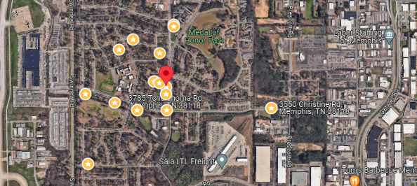

**Bed/Bath:** 3/2

**Square Foot:** 1,380

**Year Built:** 1959

Area Overview: This home is located in the airport area of Memphis. Within a few blocks one can bet at the airport/FedEx

and many other jobs that support the logistics industry. Our in house property management company currently has

properties in this subdivision, thus giving us a good presence in the area, which gives us a pulse as to the dynamics of the

area. We like this area as it is close to thousands of jobs that drive the Memphis economy, has good visibility which will

help during preiods of vacancy and does not feature any larege multi family units in the immediate area

HVAC – 2014

Roof – New

Hot Water Heater – New

Sewer inspected and all ok

Approved Resident to move in January 17, 2025