3700 Socorro Cove, Memphis, TN 38128

*Stars below represent properties under management by CB properties*

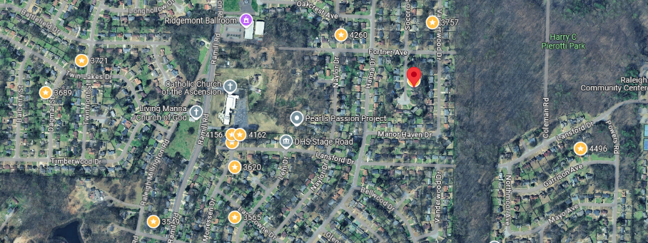

**Bed/Bath:** 3/2

**Square Foot:** 1,341

**Year Built:** 1967

Area Overview: The Raleigh area, East of Raleigh-Millington Road, is one of our largest areas of homes under management. This area has already rented quickly and for amounts that provide good cash flow. With the exception of Nike (the largest Nike DC in the US), the area economy is driven by retail, small office and businesses that support the auto sales industry. The main intersection Austin Peay and Covington Pike meet at a major intersection that includes Methodist North Healthcare Hospital on one corner and a Wal-Mart Supercenter on the other. Raleigh is one of the highest elevation points in Memphis

This home is occupied through 11/30/25

A/C - 2017

New fence in 2023

Updated by 3rd party in 2019