277 E Fairway Avenue, Memphis, TN 38109

*Stars below represent properties under management by CB Properties*

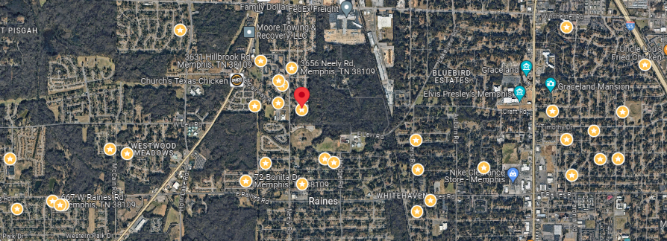

**Bed/Bath:** 3/1.5

**Square Foot:** 1,132

**Year Built:** 1961

Area Overview: This property is located in the just outside the Whitehaven area of Memphis, best known globally for Graceland, but locally, it is known for its residents pride in living within the Whitehaven area and locally owned minority businesses.

Roof - New

Hot water heater – 2011

HVAC - 2014