1453 Winfield Road, Memphis, TN 38116

*Stars below represent properties under management by CB properties*

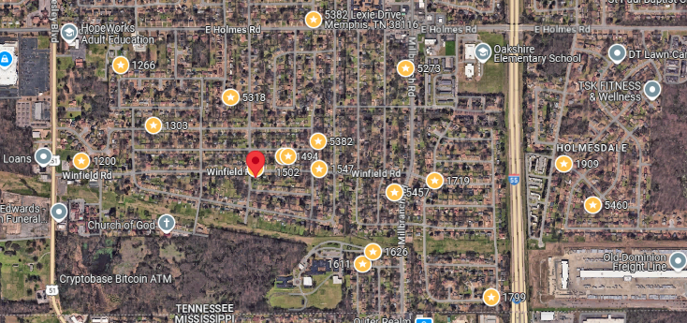

**Bed/Bath:** 3/1

**Square Foot:** 960

**Year Built:** 1959

Area Overview: This property is located in the Whitehaven area of Memphis (38116). Whitehaven best known globally for Graceland, but locally, it is known for its residents’ pride in living within the Whitehaven area and for locally-owned minority businesses. The houses are typically larger, with covered parking and a floor plan that, along with our renovation, helps properties to rent fast. Most houses in Whitehaven are 10 minutes from the airport area, which is a source for thousands of jobs. Whitehaven is the largest community that is close to the Tunica Casinos in Mississippi, also a source of thousands of jobs. Tenants in Whitehaven can reach downtown or midtown within 15 minutes. Our area of Whitehaven is exclusive to West of Elvis Presley, East of Millbranch.

A/C – 2012

Furnace – 2019

Hot Water Heater – 2019

Roof – 10 – 15 years

Home is occupied through May 21, 2026